|  |
| --- |
| SCM HW2 Group 1 |
| Advertising Analysis |
| Google Analytics – Syracuse University |

|  |
| --- |
| Alexandra A Rosser, Nicholas Starr, Jared M Mosley & Sathish Kumar Rajendiran  5-8-2020 |

 In previous advertising campaigns at Syracuse University, varying results were returned. Below we will discuss time frames and cost of each campaign, as well as their effectiveness.

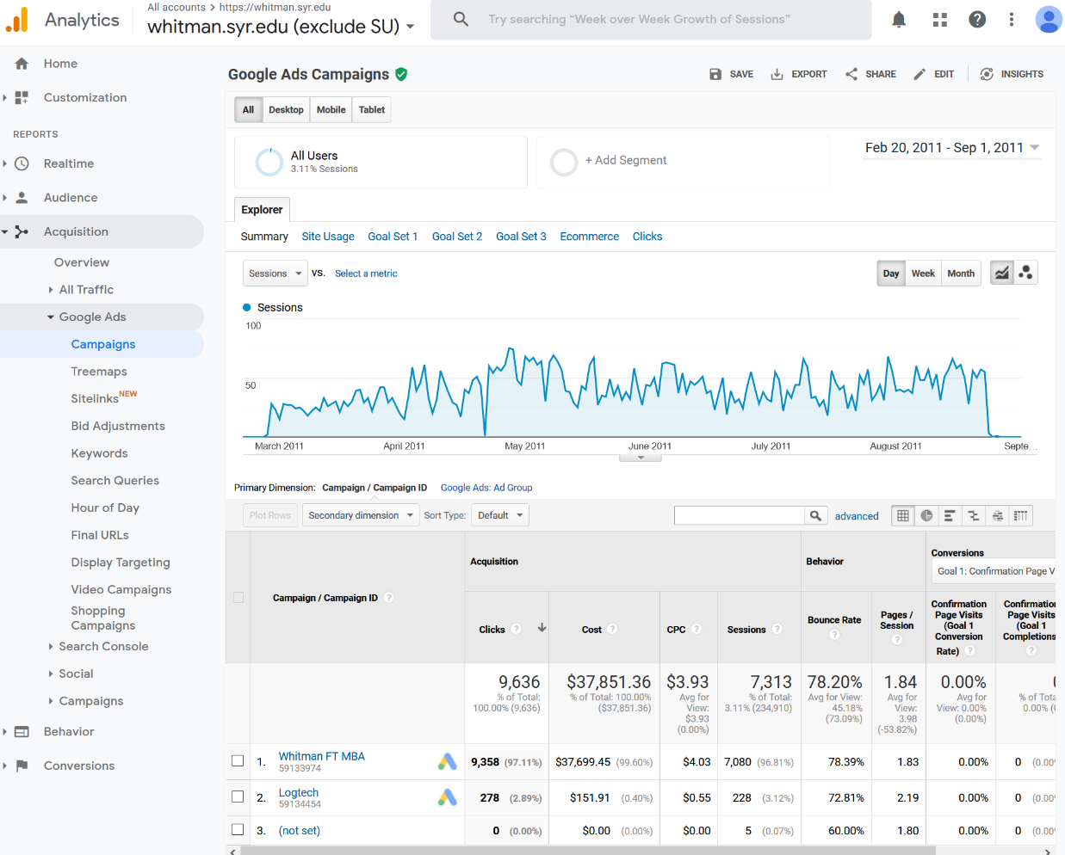During the Whitman.syr.edu campaign, which ran from February 20, 2011 – September 1, 2011, a total of $37,851.36 was spent in advertising dollars. This campaign returned 9,636 clicks coming in at a $3.93 cost per click, which is the second lowest amongst all campaigns. Its click total was the highest amount, and it had the second lowest bounce rate at 78.2%, and second highest pages per session at 1.84. From those that clicked, there were 7,313 sessions, or active users engaged. Ultimately, we believe this to be the most effective campaign from Syracuse. At a middle-of-the-road spending level, this campaign brought in the most clicks and sessions, at a better bounce rate than the other major campaigns.

The MBA Marketing Full Time campaign revealed two segments. The first segment was from January 10, 2012 through February 10, 2012, costing $9,927.44. This campaign had the lowest cost per click, but also held the highest bounce rate at 97.71% as well as the lowest pages per session at 1.03. This first campaign segment was not very effective.

The second segment from October 20, 2012 – July 10, 2013 cost a total of $75,487.35. This campaign attracted 7,392 clicks for a total cost per click of $10.21: much higher than previous campaigns. The bounce rate was higher than the Whitman campaign at 82.5% and brought 4,286 sessions. The second segment of the Marketing Full Time campaign was almost twice as expensive as the Whitman campaign, and brought in just over half the sessions, proving to be not very effective.

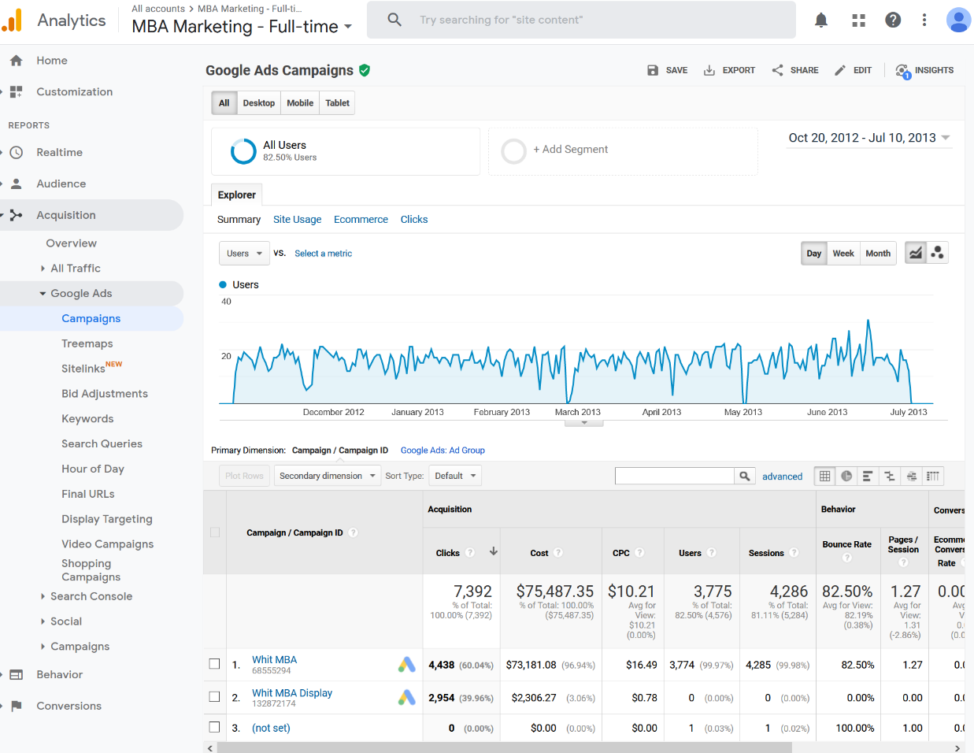

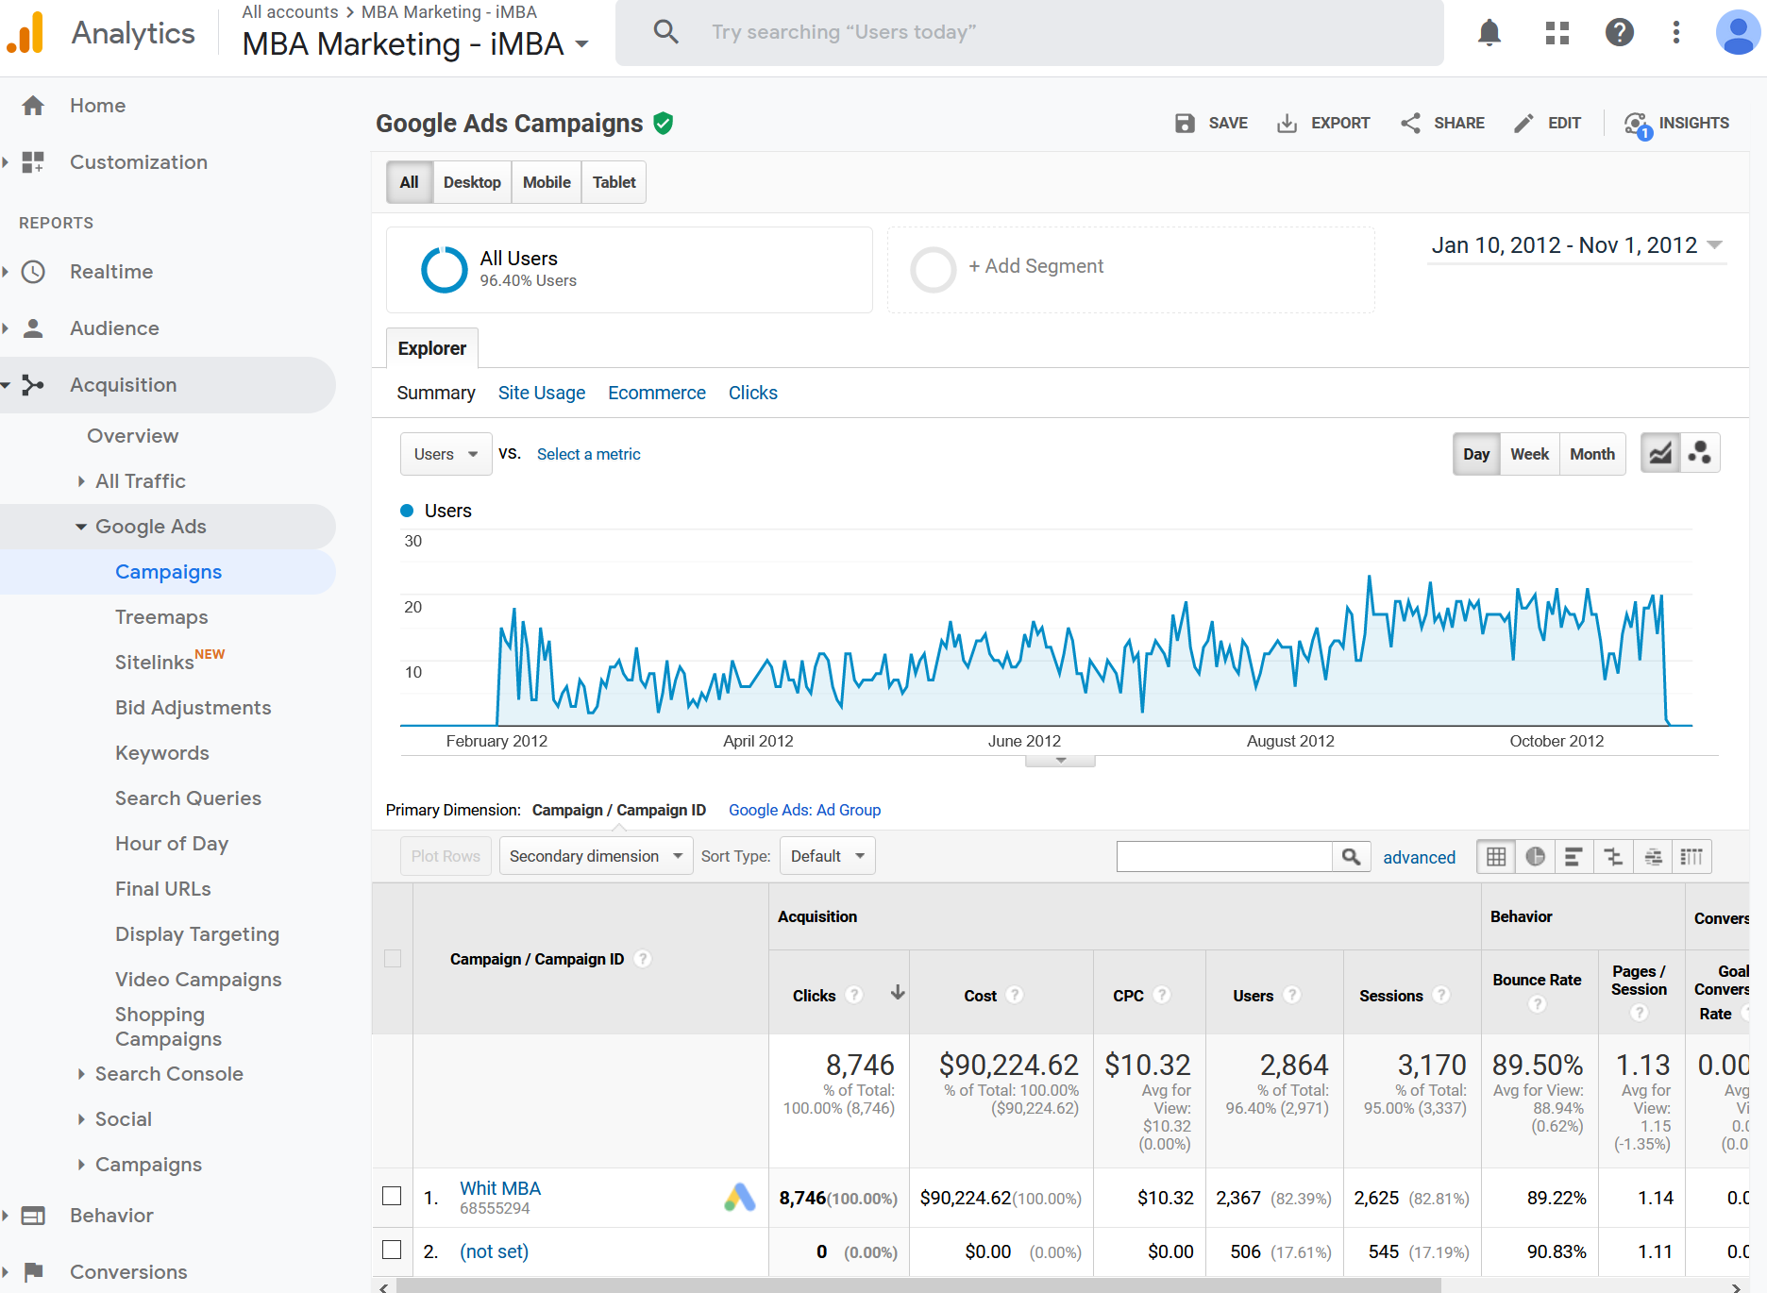The third campaign, MBA Marketing – iMBA, was the most expensive at $90,224.62 and ran from January 10, 2012 – November 1, 2012. The iMBA campaign had the highest effective cost per click of $10.32, returning 8,746 clicks. It had the second highest bounce rate of 89.5% and the second lowest pages per session of 1.13. Returning only 3,170 sessions, this campaign was the least effective of the major campaigns.

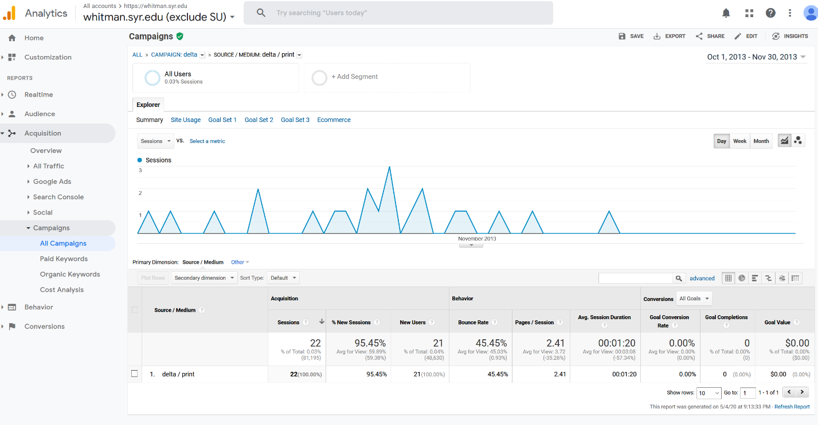The final campaign was a minor 1-month paper campaign for Delta airlines, costing only $10,000 from October 1, 2013 – November 15, 2013. Though holding the best bounce rate of 38.89% and highest pages per session at 2.67, this campaign only shows 18 sessions. Effectively, this campaign had the most limited reach at its cost and was not effective, perhaps explaining its short time frame.

Using this information, we can understand what sort of levels we would want to achieve for our own advertising campaign: a low cost per click at around $3.00, a modest bounce rate in the 70% range, and a low cost per session. To evaluate key aspects of our campaign, we will now determine prime geographic areas as well as key words and advertising times.

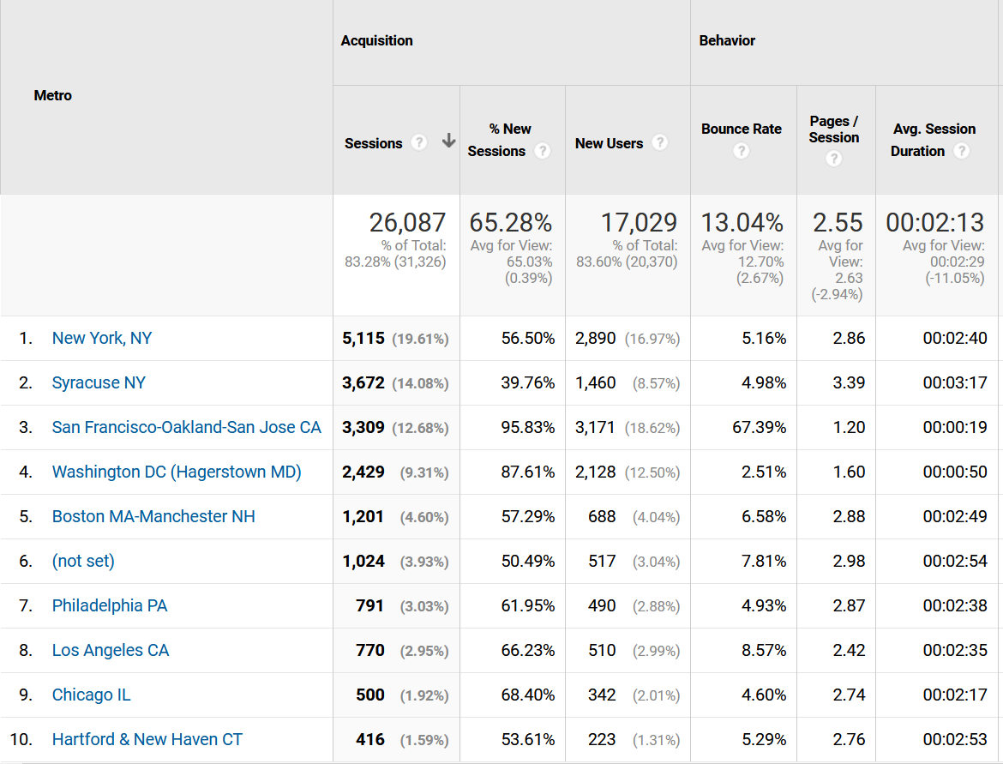Adjusting our viewing time frame to something more recent and looking at the past year, geographically we can determine that the most popular states are New York, California, and Virginia. New York makes sense, as it is the home state of the University, and California contains a lot of the jobs our degrees feed into. Following up the top spots, many of the states are regionally located in the northeast US, with the exception of Texas and Florida. Of the states, California has the largest bounce4 rate, and all others have low bounce rates less than 10%. Looking at the metros, New York, Syracuse, and San Francisco have the most sessions. San Francisco, mirroring that of California, has the largest bounce rate, and all others are also below 10%. Ultimately, we would focus our advertising on the Northeastern region of the US, where Syracuse University has the most name recognition. We would target NY as a whole, and larger cities in the surrounding area, such as Boston, Philadelphia, Chicago, and Washington D.C. We will also target California, focusing on San Francisco and Las Angeles, as there is still great opportunity in those regions.

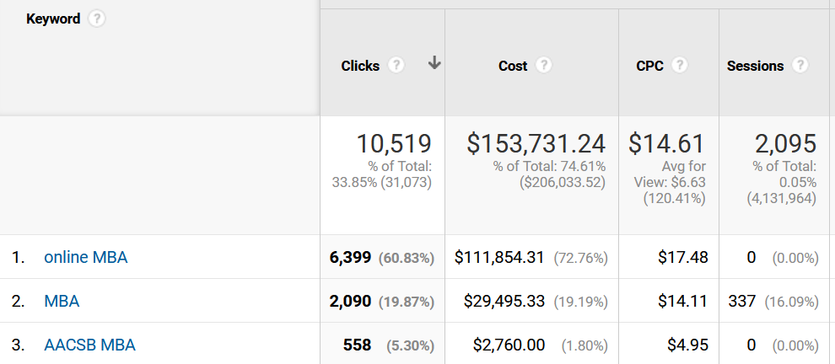Looking at keyword data from 2010, we would really focus on the same terminologies. Any combination of “Online,” “MBA,” and “AACSB MBA’” bring back more than 80% of the results, and we do not foresee that changing any time soon.

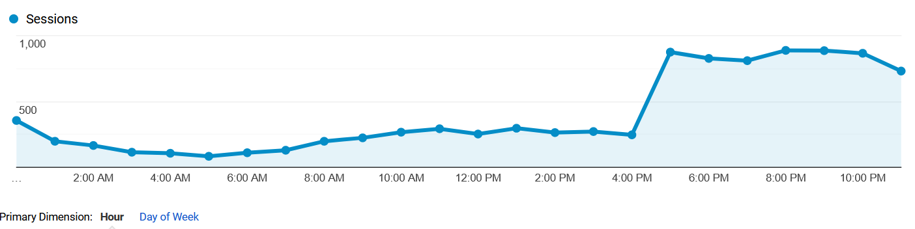As for time of the day and day of week, sessions spike after 4:00pm and before Midnight, so we will isolate those times as well to get the best utility. The days of the week are almost all relatively smooth, with the exception of Friday being the lowest. It is not too significant, though we will opt for advertisements to run Saturday – Thursday to save costs.

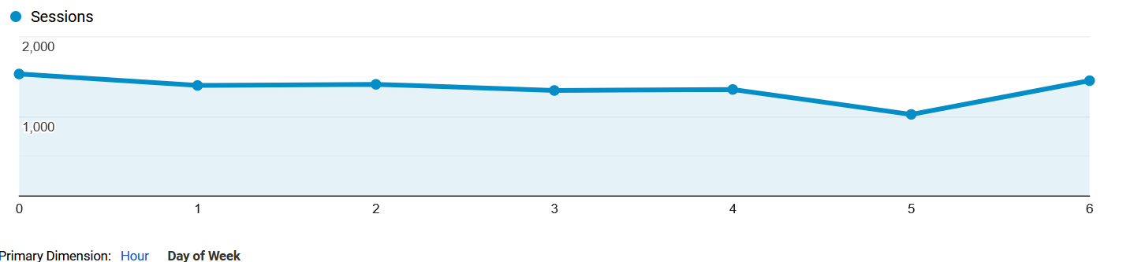

For our advertisement campaign, based off the information above we will focus our spending as follows:

* Regionally:
  + Northeast: 85%
    - Isolating the bulk of New York state, followed by the surrounding metros of Washington D.C., Boston, Philadelphia, and Chicago.
  + California: 15%
    1. Here we will mainly focus on San Francisco and Los Angeles.
* Degree Plan:
  + Online: 75%
    - Being that the nation is working from home more, and many are considering going back for their MBA with more spare time on their hands due to the COVID-19 crises, we will focus the majority of our spending on all of our online degree plans.
  + Full-Time: 25%
    - Spending the remaining budget on our full-time MBA options, and focusing these much closer to Syracuse, essentially just New York state and surrounding regions.

We will measure our performance based off of prior metrics, such as a low cost per click and a low bounce rate, but ultimately on fill rate of the programs feeding from the advertising campaign. Ultimately, the goal is to turn interested potential students into applications to the various MBA programs offered by Syracuse University. We would try to track the user from click to application, and hopefully be able to verify a percentage of new enrollment that came from our advertisement. The expected return from tuition payments and application fees from admitted students and applicants we would weigh against our advertising costs to get a better understanding on the return.

Other factors worth considering are potentially targeting through Facebook certain people in career fields where our degrees would be valuable in helping them get ahead. Also, we could target demographics of recent bachelor’s degree graduates of similar or prerequisite programs both locally and in the regions mentioned above. Lastly, we can target potential applicants that may be looking into boot camps for programs like data science in attempt to place more value on going for an MBA instead.